Jenkins task 2
TASK 1: Configure 2 Slave (Agent) Machines in Jenkins Master
Objective
To configure two Jenkins slave (agent) machines and connect them to the
Jenkins master using SSH, then verify by running jobs on the slaves.
—> Steps on Slave Machine-1 (slave-01)
Steps to be done on slave
—> Login to slave machine..
—> switch to root user
—> install jdk 11 (amazon-linux-extras install java-openjdk11)
—> Create ssh-keygen
—> cat id_rsa. pub › authorized_keys
—-> chmod 700 authorized keys
Step 1: Create EC2 Instance
• Name: slave-01
• OS: Amazon Linux 2023
• Allow SSH (22)
Step 2: Login & Switch to Root
ssh -i key.pem ec2-user@<slave-01-ip>
sudo su -
Step 3: Install Java
dnf install -y java-17-amazon-corretto
Verify:
java -version
Step 4: Generate SSH Key
ssh-keygen
(Press Enter for all prompts)
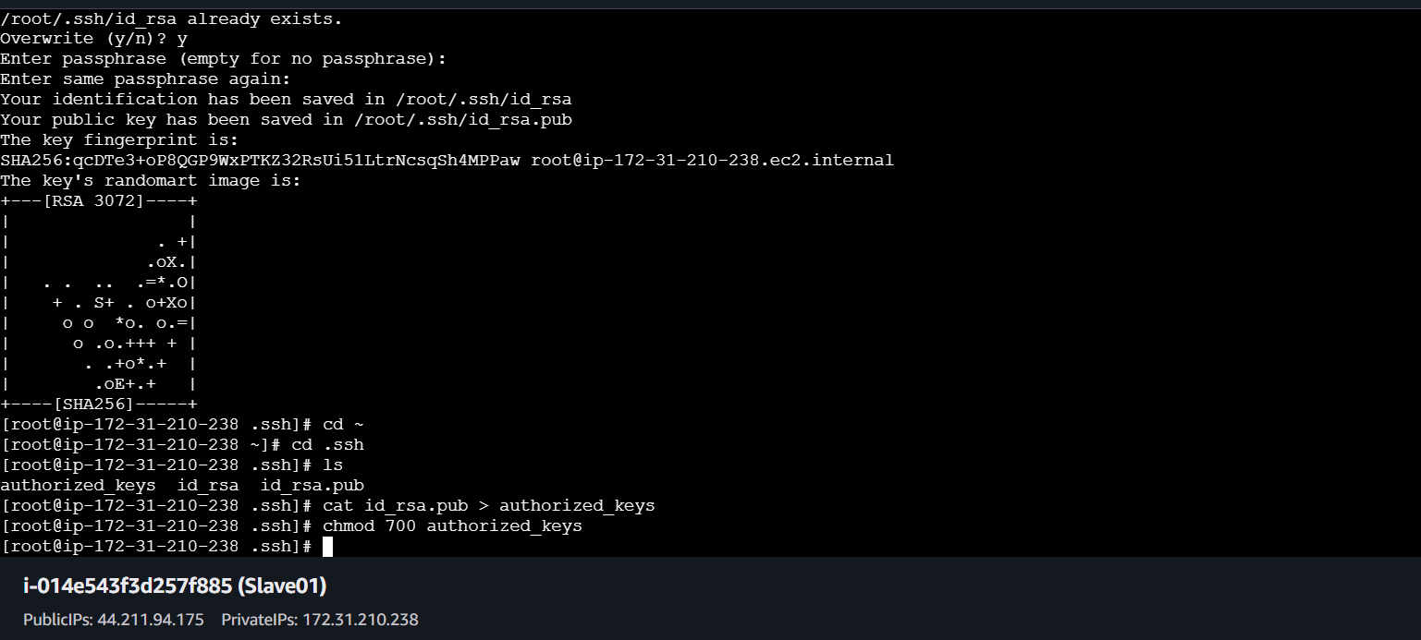

Step 5: Configure Authorized Keys
cd ~/.ssh
cat id_rsa.pub > authorized_keys
chmod 700 authorized_keys

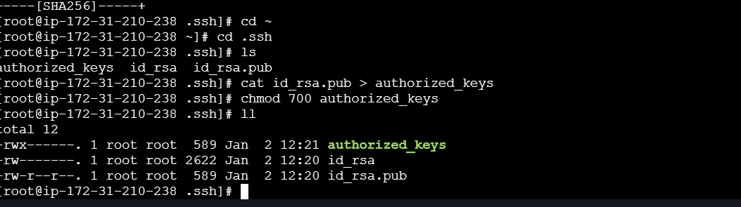

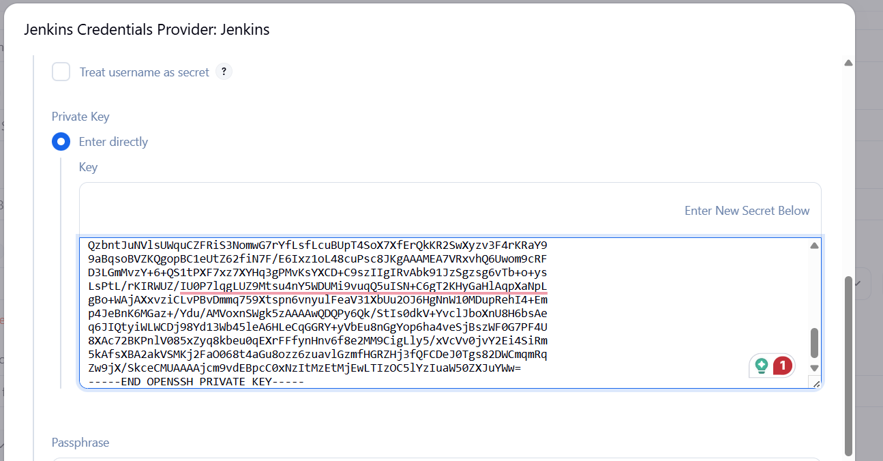

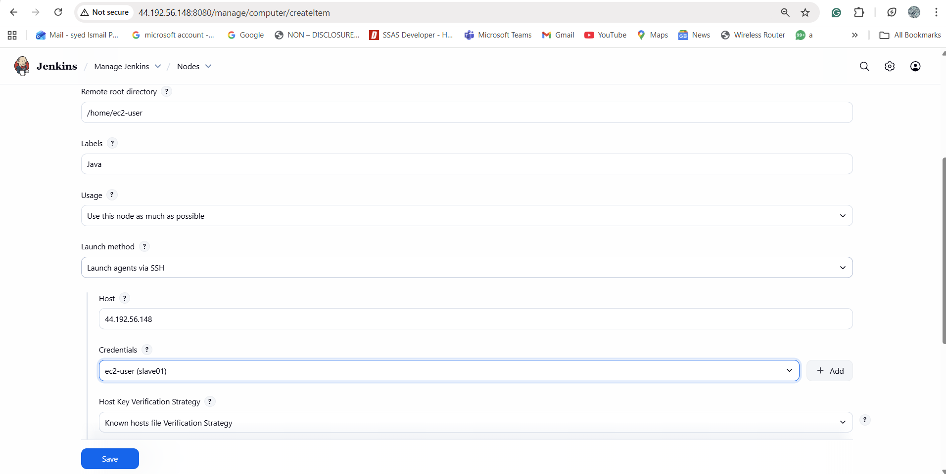

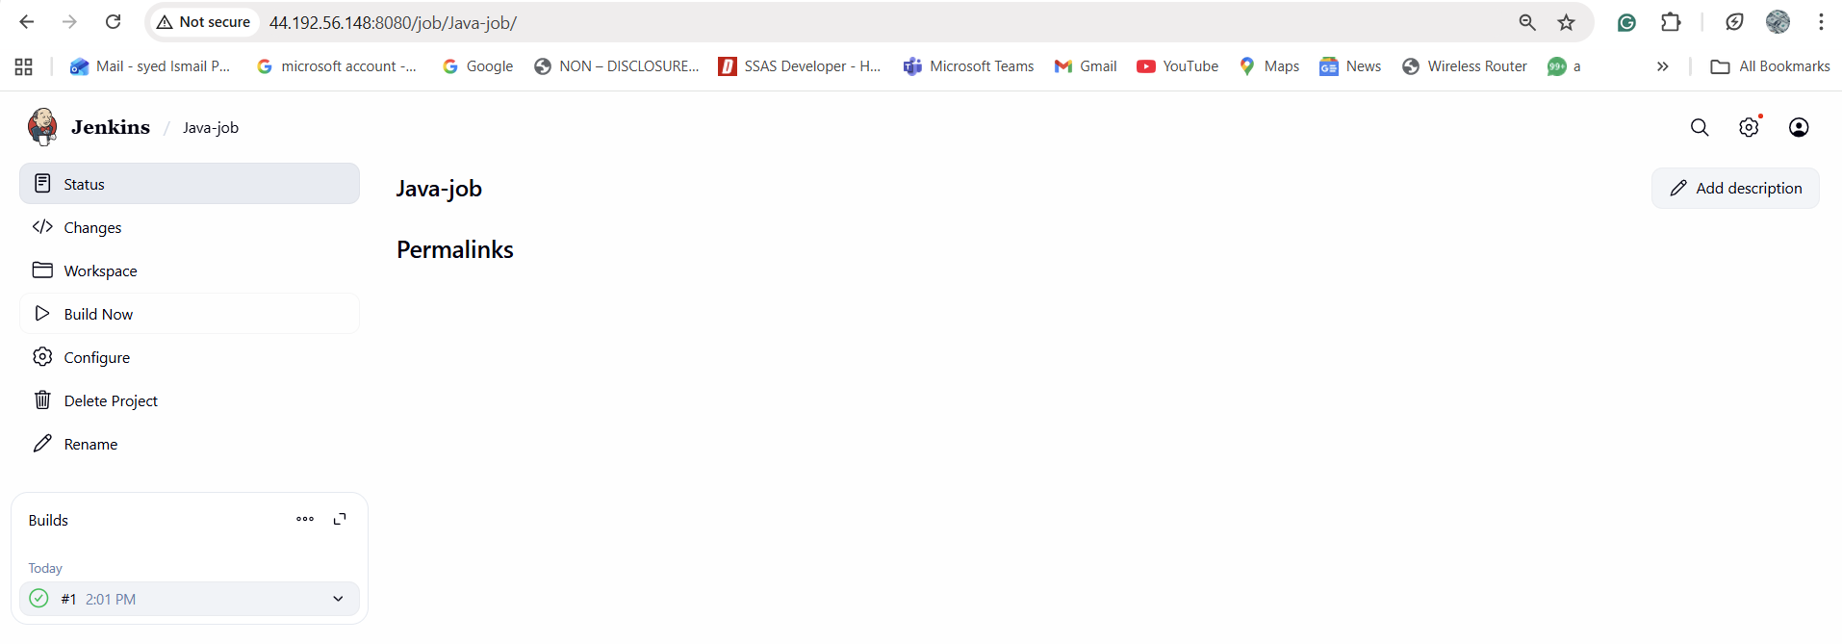

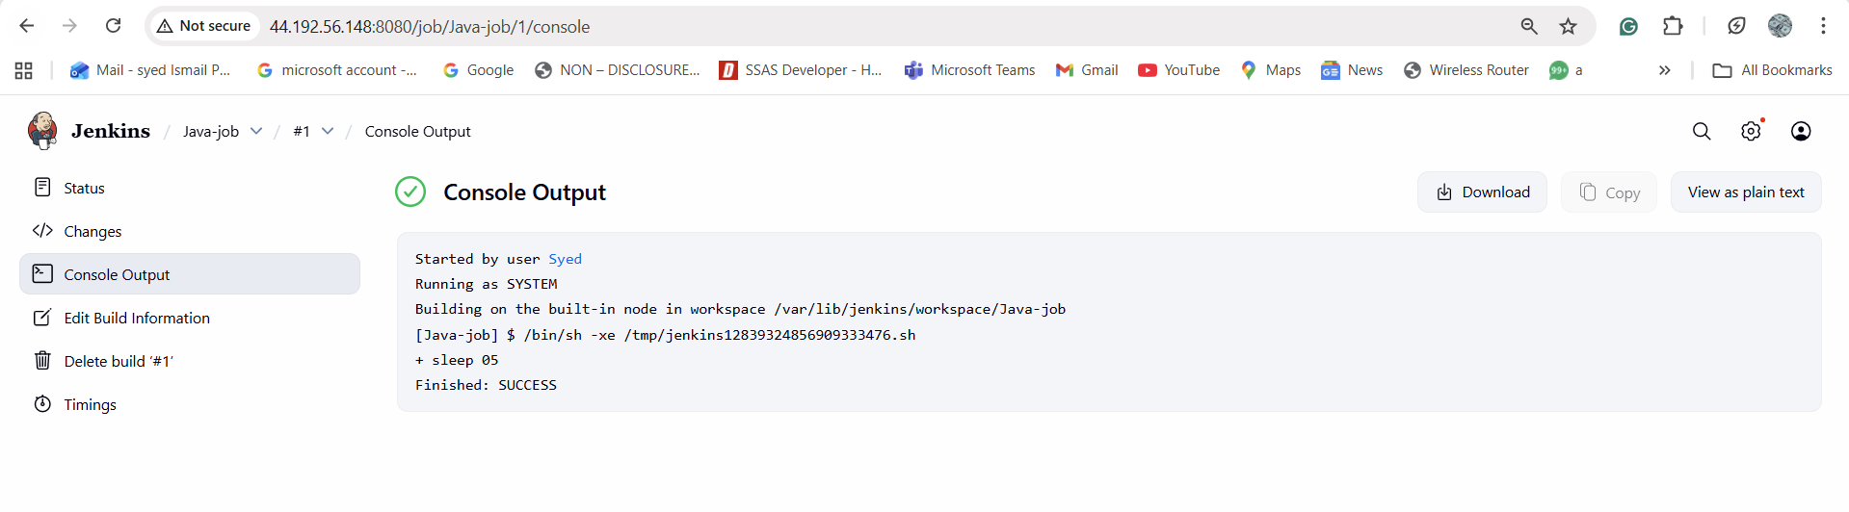

Task 2: Configure Webhooks to Jenkins Job (GitHub)
Prerequisites
• Jenkins job with Git repo
• GitHub repository
• Jenkins accessible publicly
• GitHub plugin installed
In Jenkins Job
1. Job → Configure
2. Source Code Management → Git → Add repo URL
3. Build Triggers → GitHub hook trigger for GITScm polling

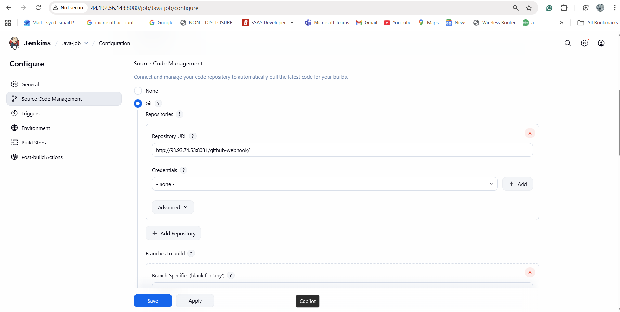

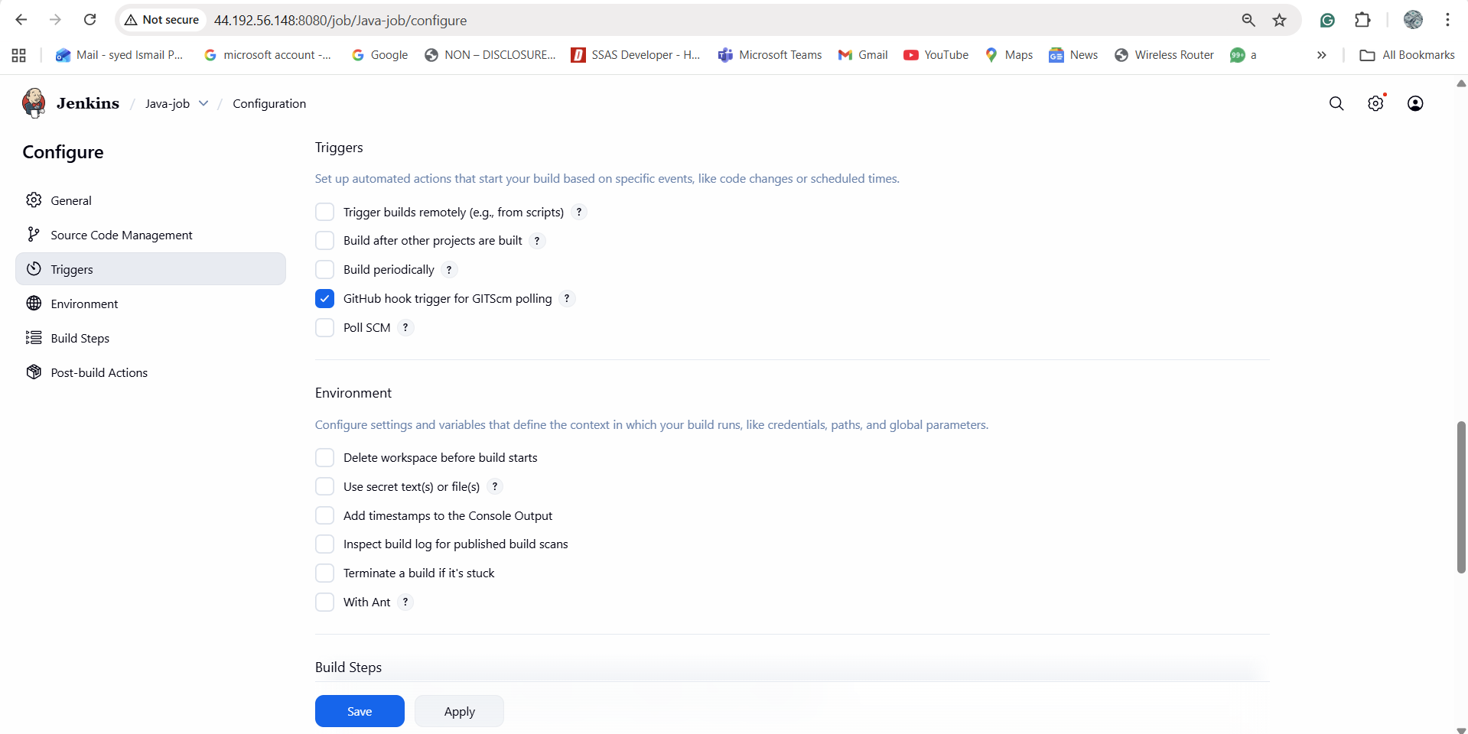

In GitHub Repo
1. Repo → Settings → Webhooks → Add webhook
2. Payload URL:
3. http://98.93.74.53:8081/github-webhook/
4. Content type: application/json
5. Select: Just the push event
6. Add webhook

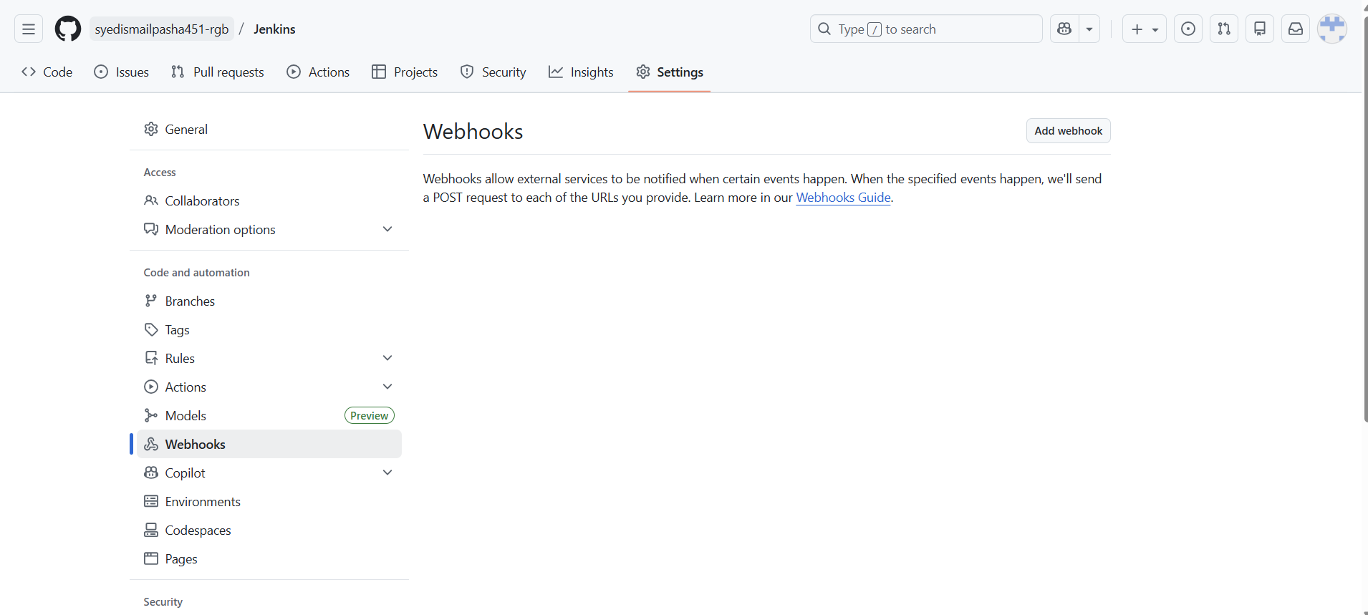

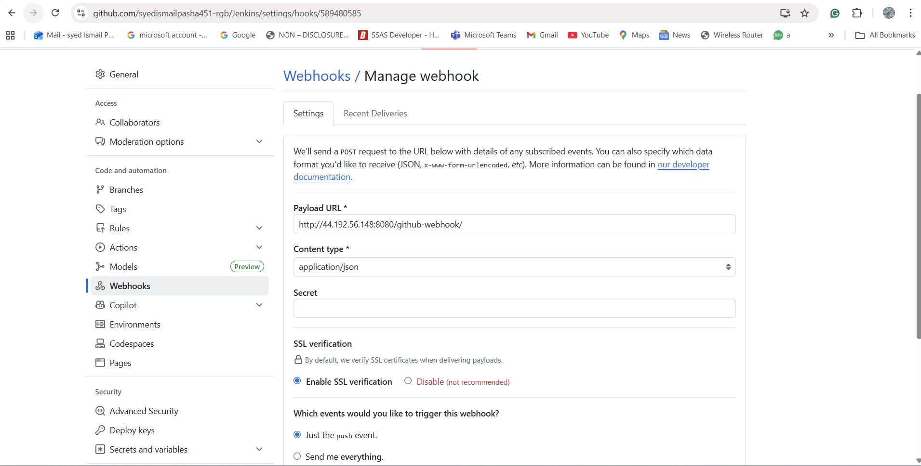

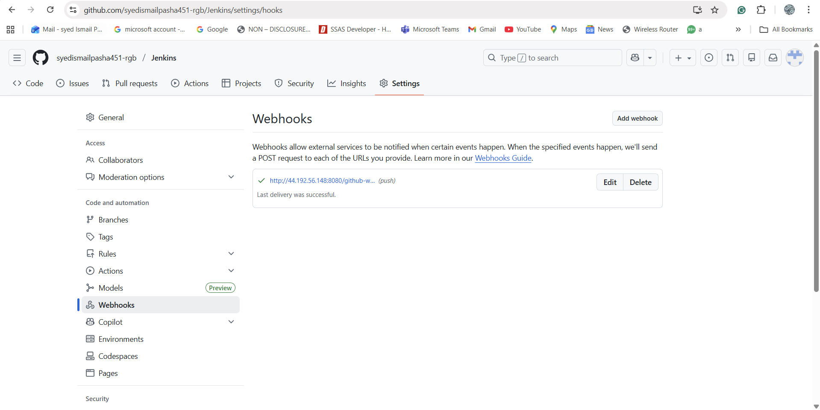

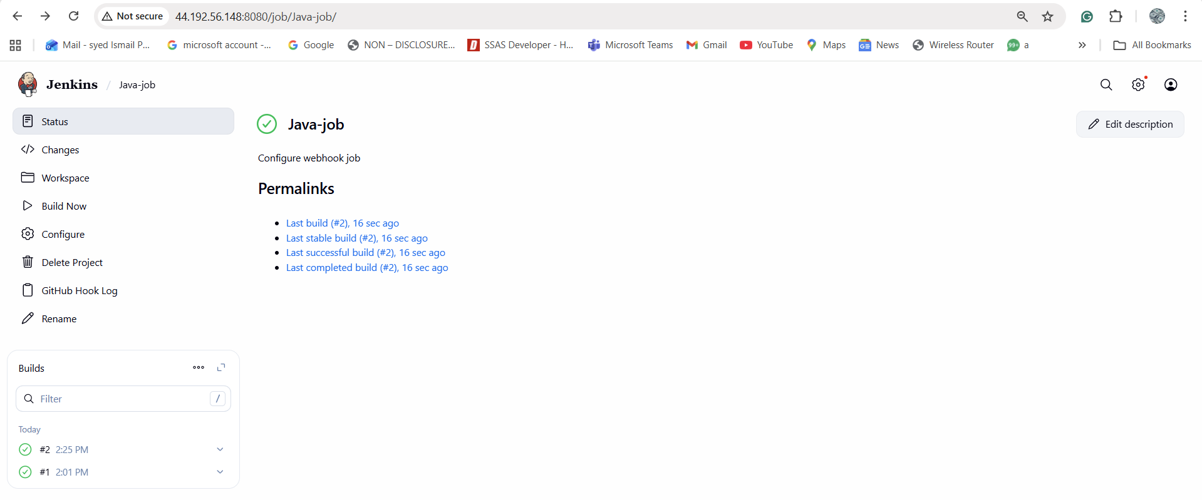
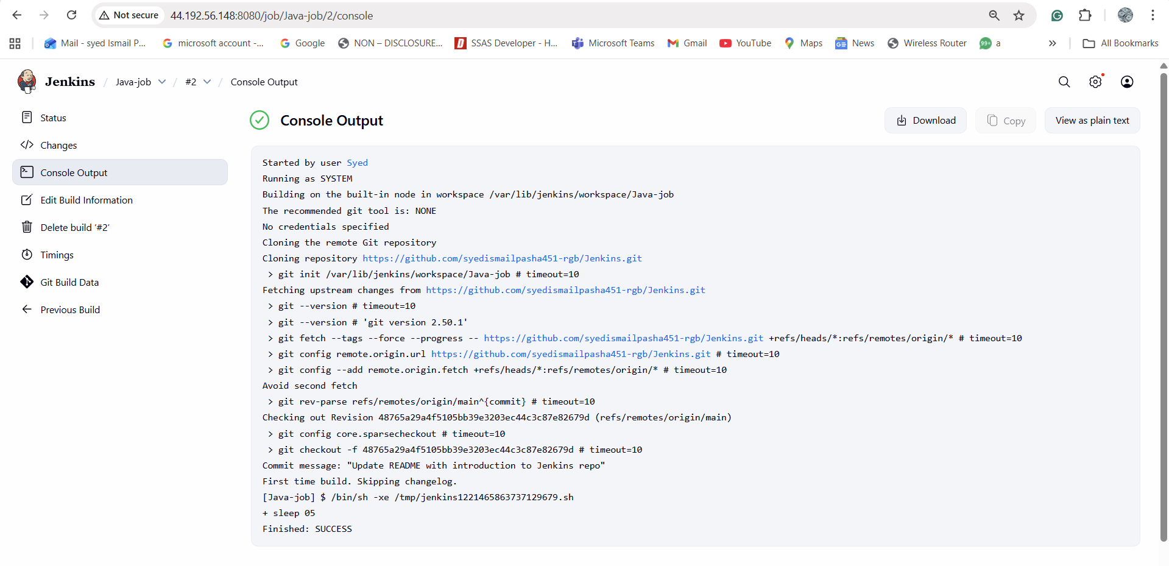

Task 3: Configure poll SCM and build periodical options in Jenkins job.
Open Jenkins Job → Configure → Build Triggers
Poll SCM
Build only when code changes.
Check Poll SCM, add:
H/5 * * * *
Poll every 5 minutes.
Validation:
Build Periodically
Build at fixed time.
Check Build periodically, add:
* * * * *
Build periodic for every minutes.
Cron format:
MIN HOUR DOM MON DOW

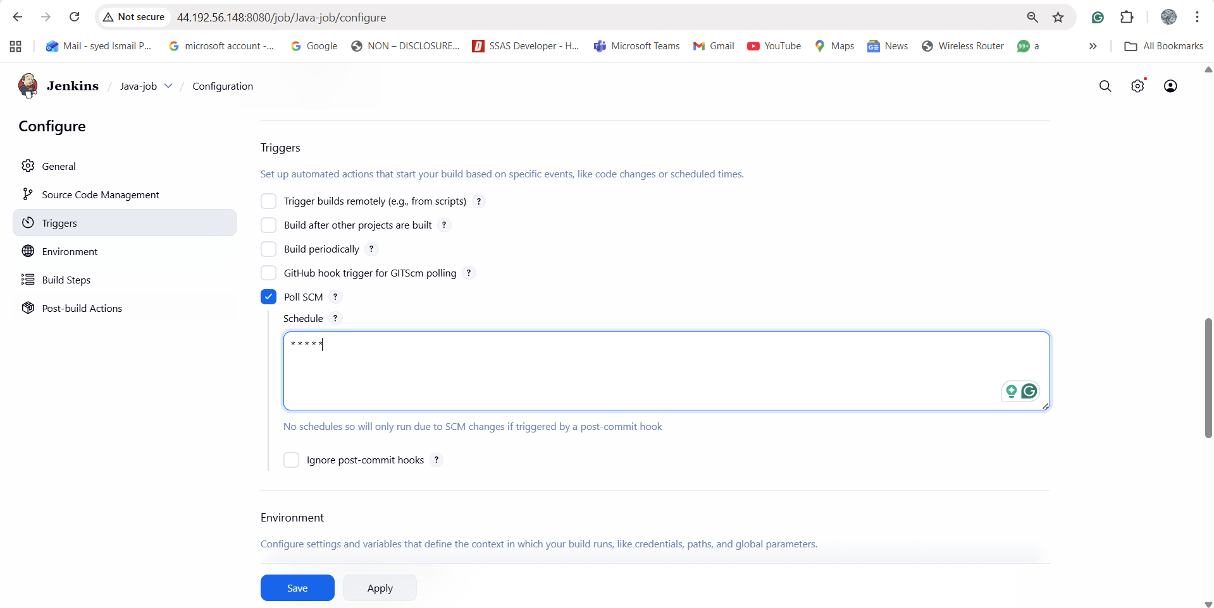

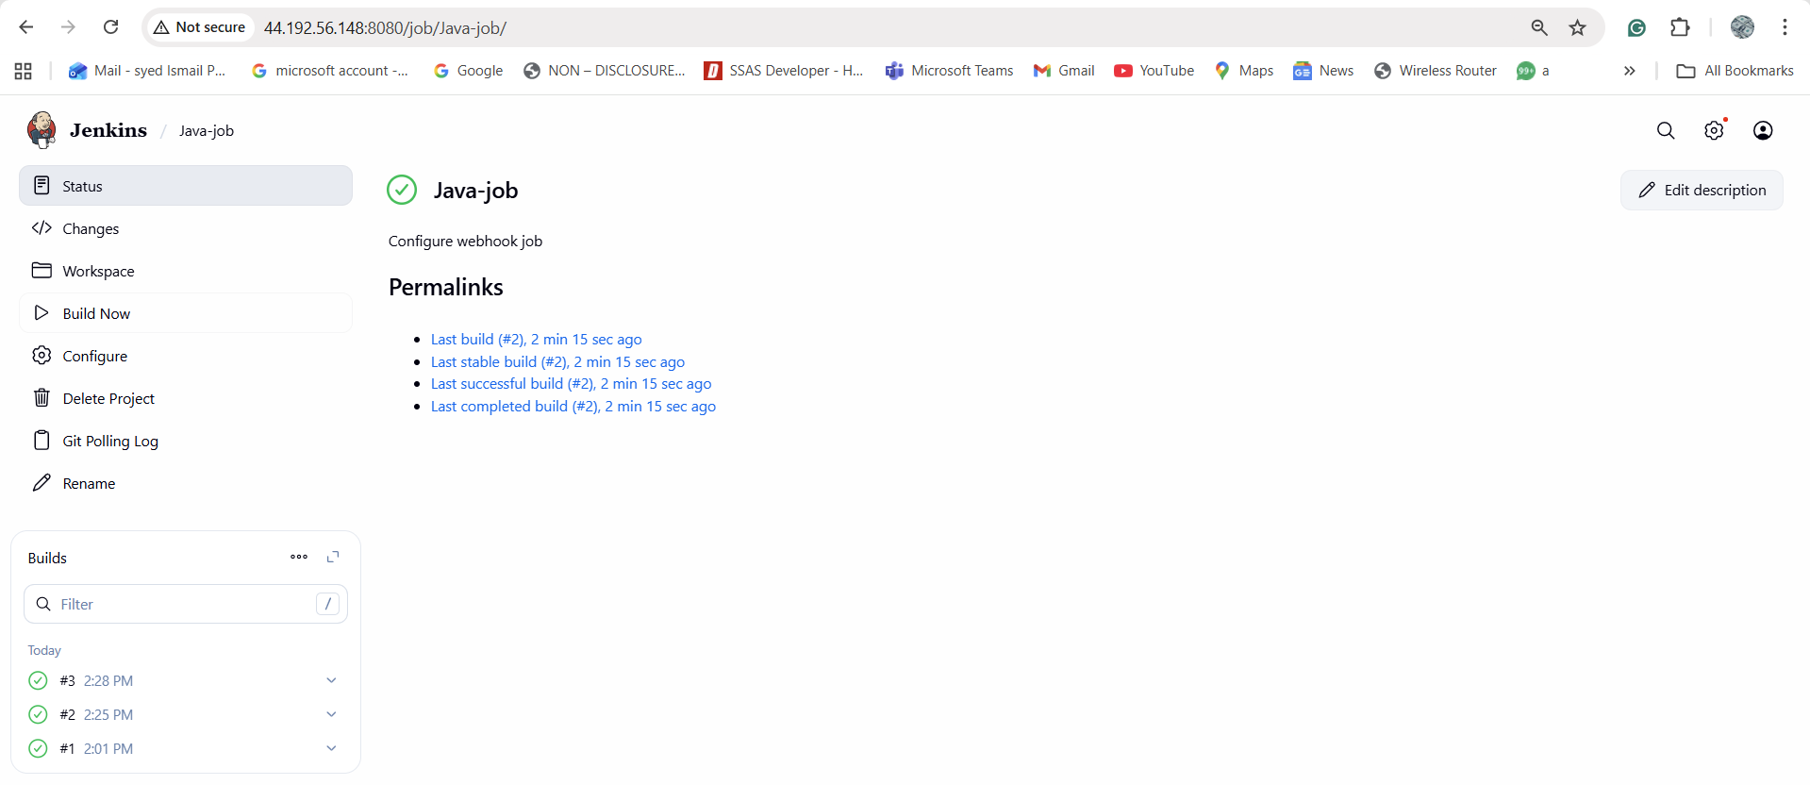

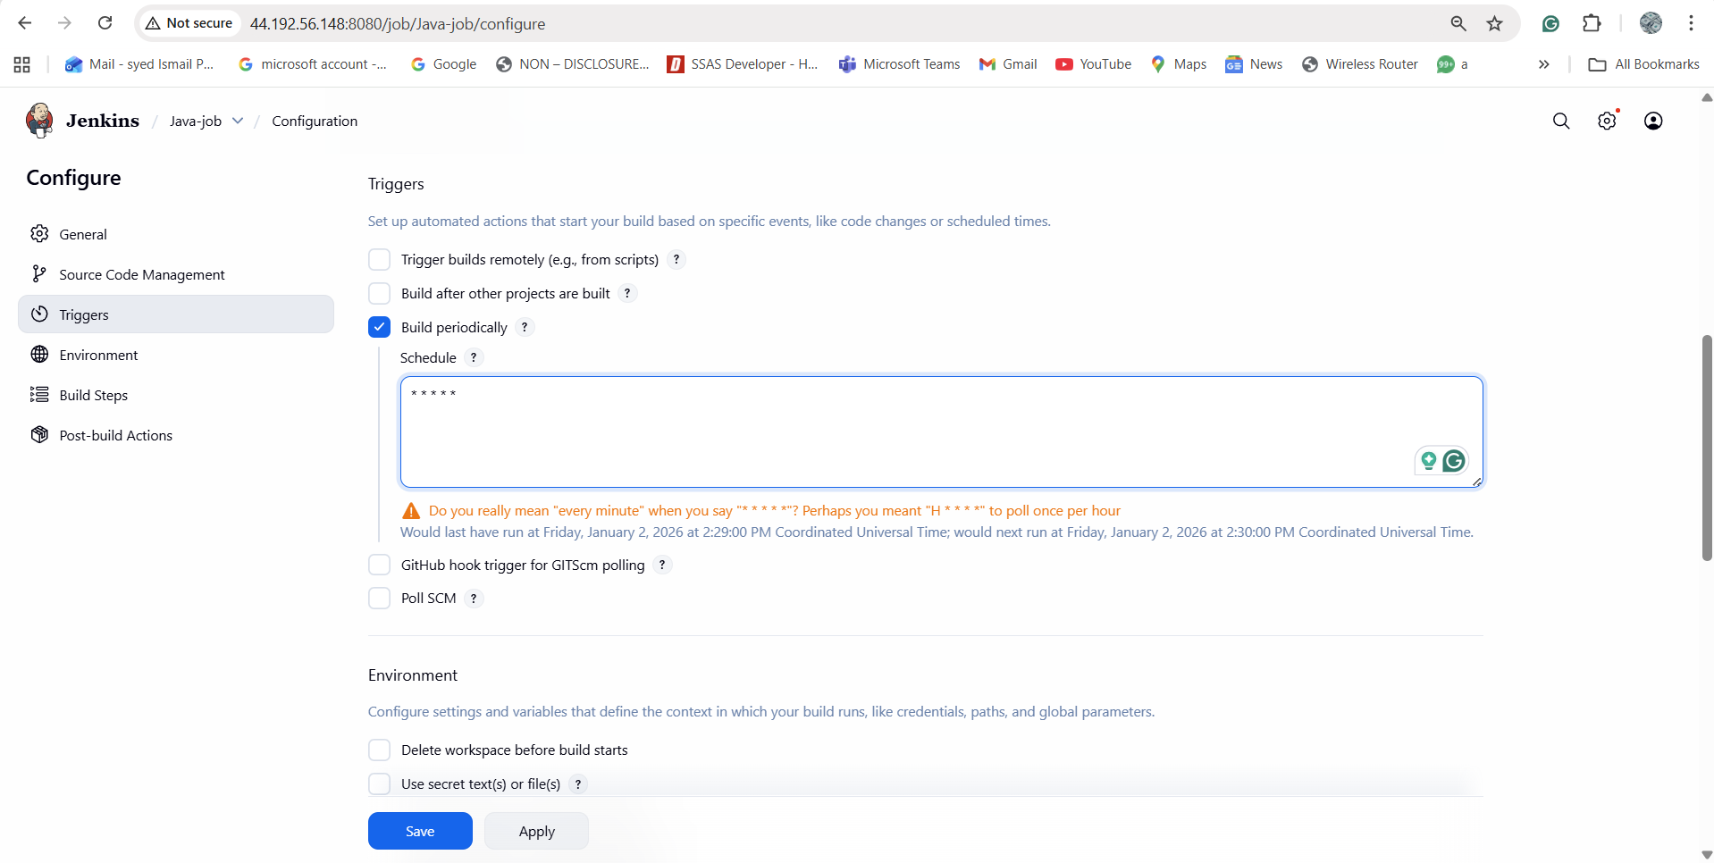

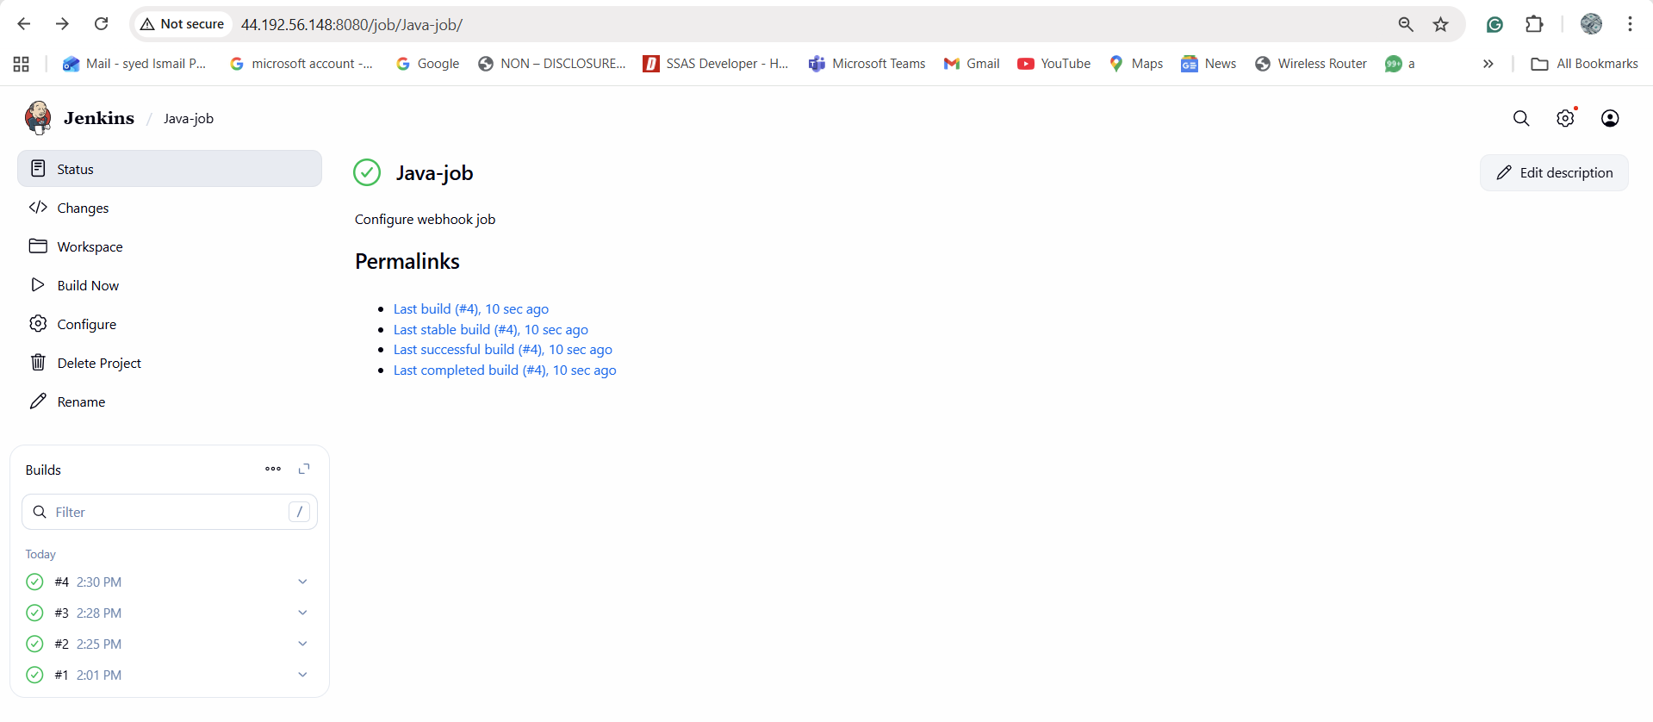

Task 4: Take backup of Jenkins server by using bash script.

◊Jenkins Home
/var/lib/jenkins
Create Script
sudo mkdir -p /backup/jenkins
sudo vi /backup/jenkins/jenkins_backup.sh
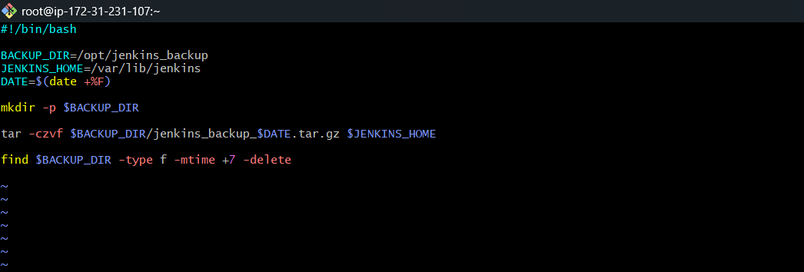

Took backup
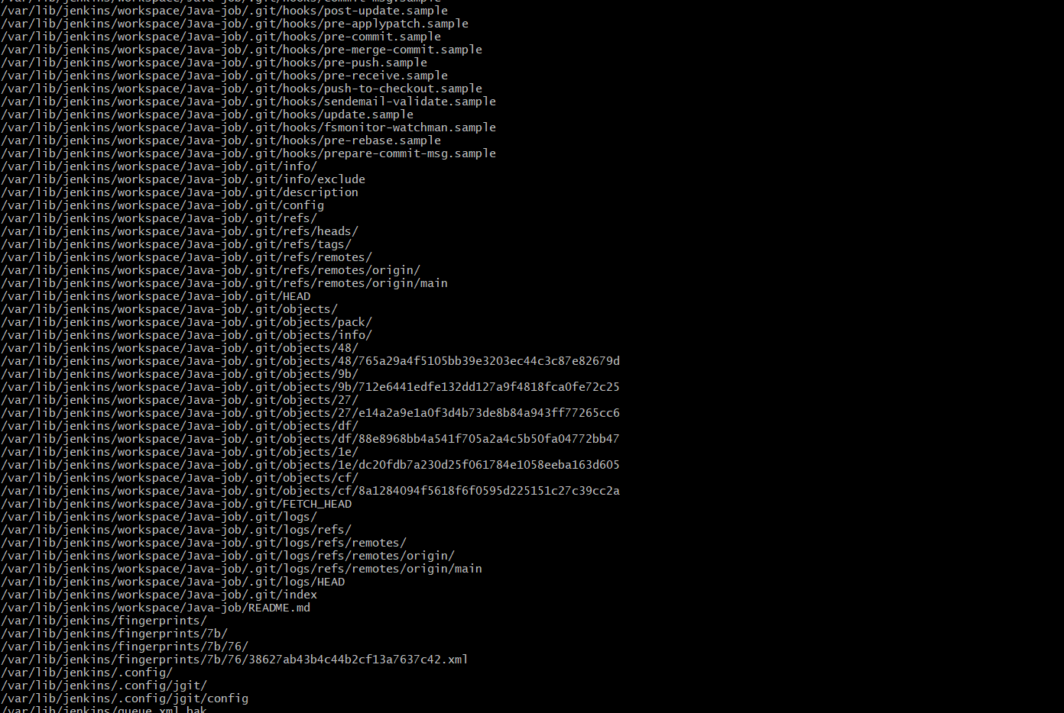

ls -lh /opt/jenkins_backup

Task 05
Task 5: Take backup of Jenkins using rethin backup plugin.
Install Plugin
1. Manage Jenkins → Manage Plugins → Available
2. Search ThinBackup
3. Install & restart Jenkins.
Configure ThinBackup
1. Manage Jenkins → ThinBackup → Settings
2. Backup directory: /backup/thinbackup
3. Backup build results (optional)
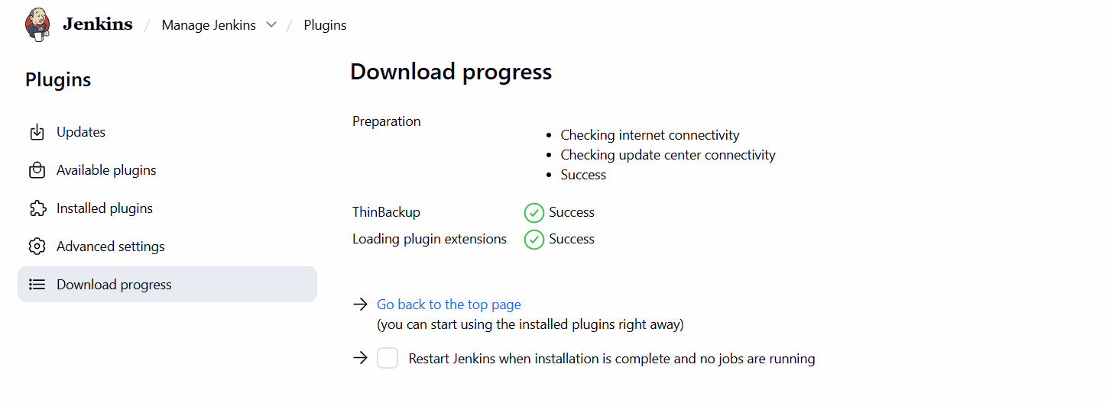

Restart Jenkins

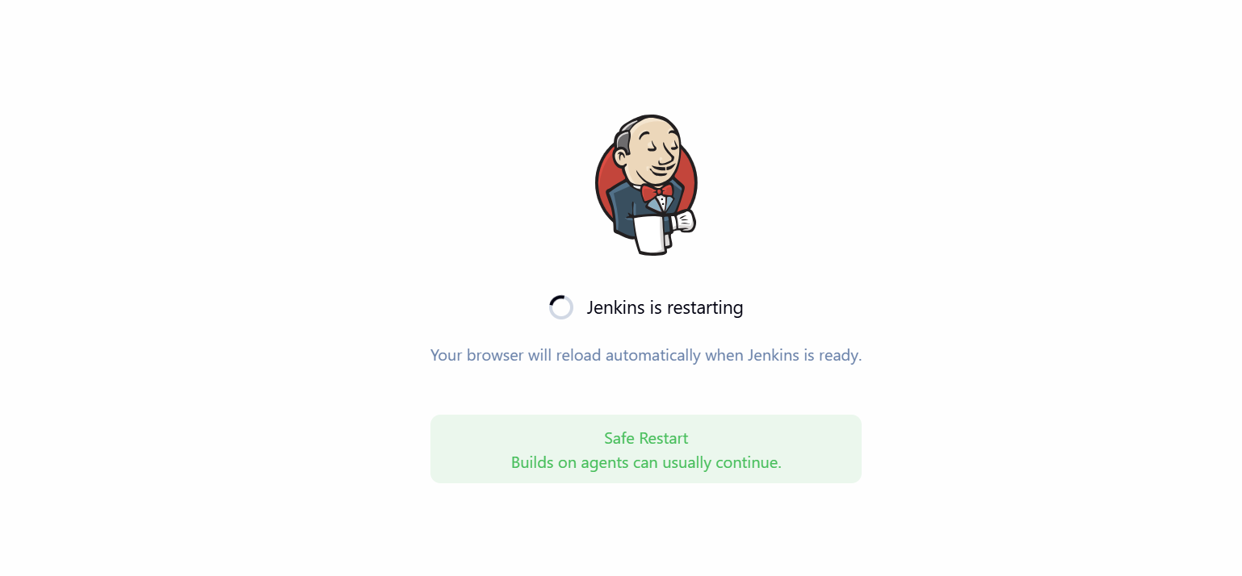
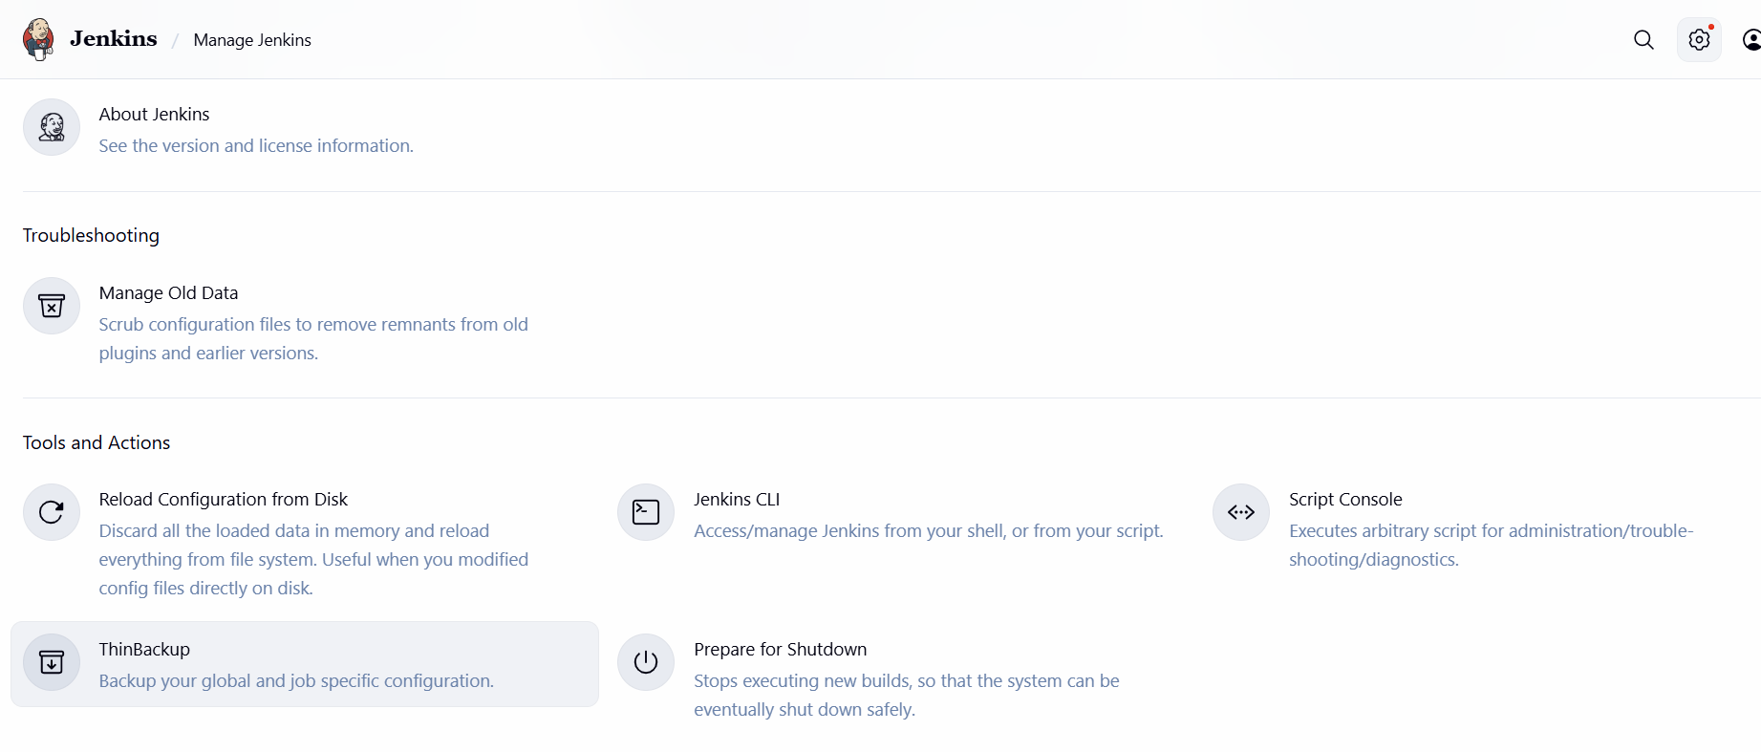

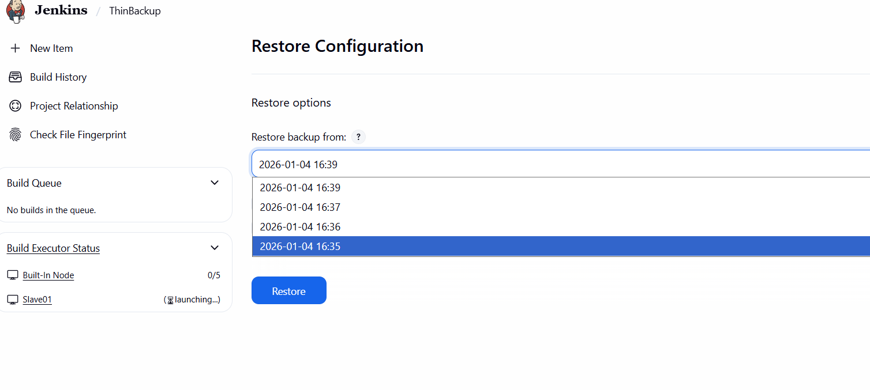

Task 6: Setup a new Jenkins server and dump the backup taken in task4

Step 1: Install Java
sudo yum update -y
sudo yum install -y java-11-openjdk
Step 2: Install Jenkins
sudo wget -O /etc/yum.repos.d/jenkins.repo \
https://pkg.jenkins.io/redhat-stable/jenkins.repo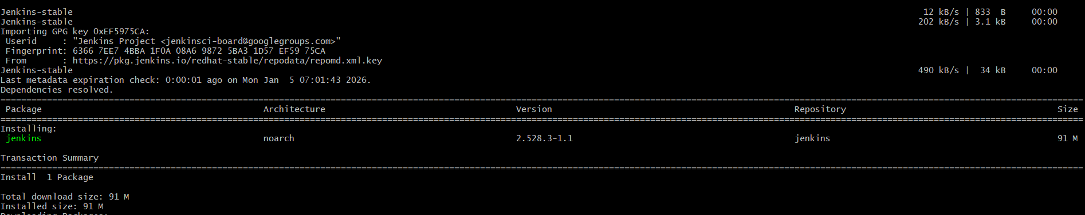
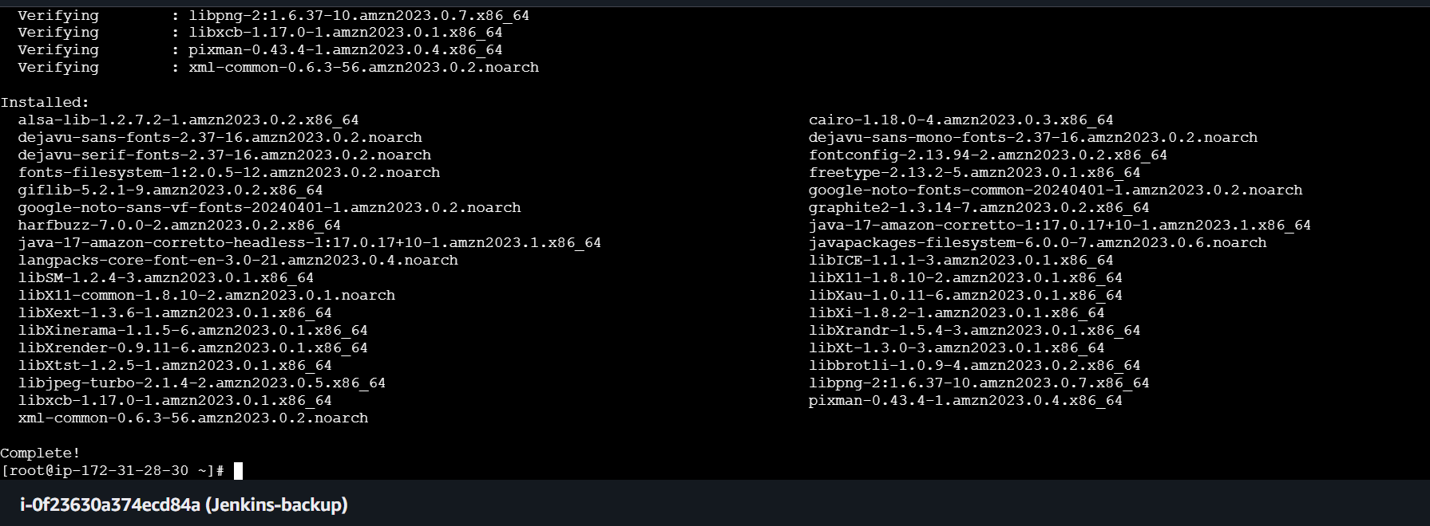
Systemctl status Jenkins
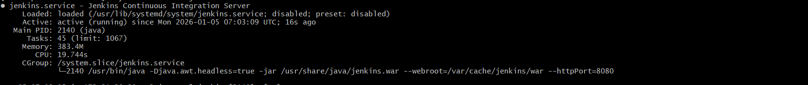

Adding pemkey and change the pwermissions
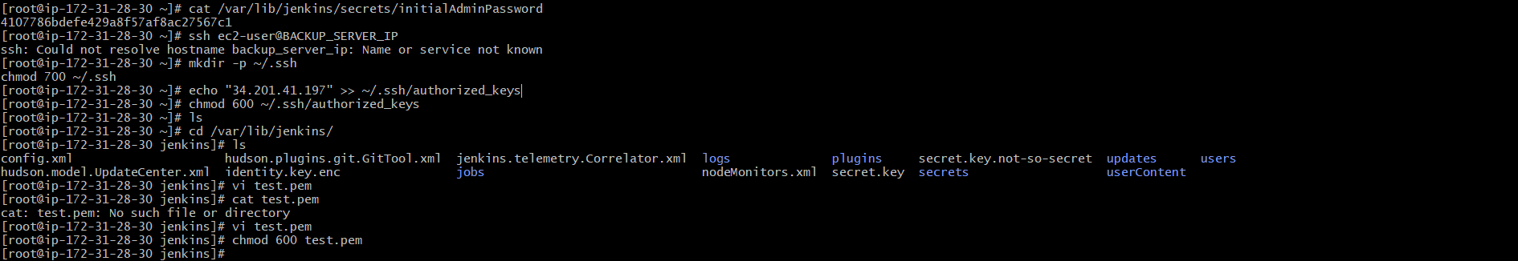
Command
mv /opt
scp -i test.pem /opt/jenkins_backup/jenkins_backup_2026-01-04.tar.gz ec2-user@3.94.78.2:/tmp/

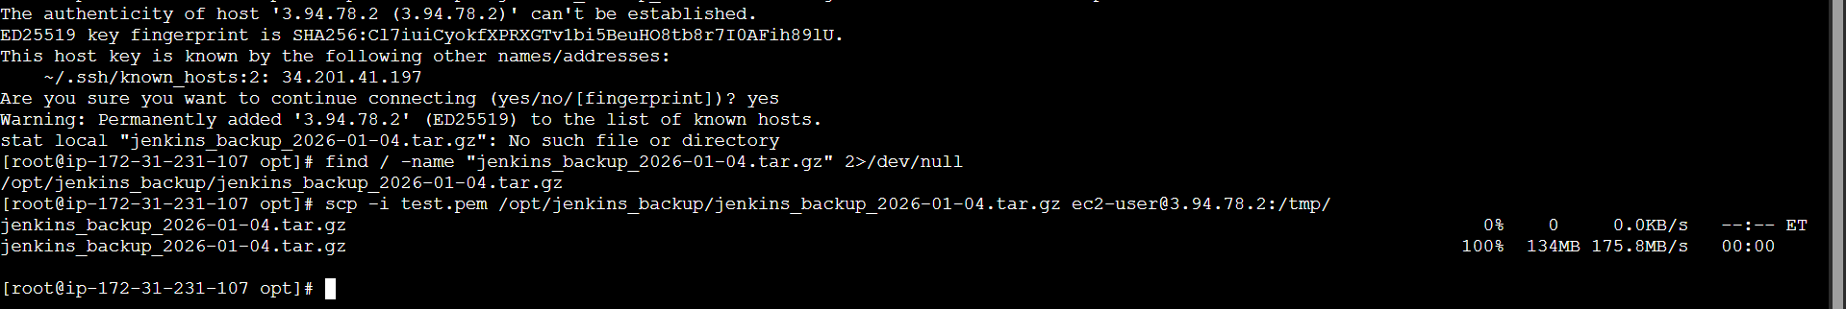
Successfully created backup in backup server
